Chapter 9 Homework Problems

Problem 9.1

A 50kg box is being pulled across a surface by a 200 N force in the direction shown below. If the static coefficient of friction is .3, what is the rate of acceleration of the box and how far will the box move in a three second period?

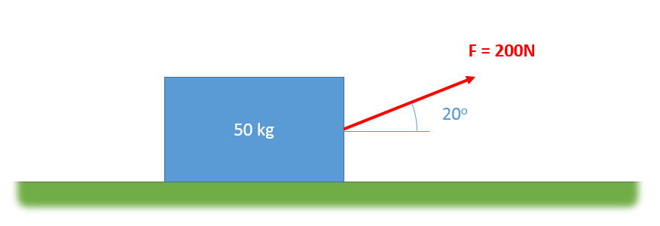

(Solution: a = 1.23 m/s2, s = 5.52 m)

Problem 9.2

A three-kilogram cannonball is shot out of a cannon with an initial velocity of 300 m/s at a 25o angle. A headwind exerts a constant 5 N horizontal force. How far will the cannonball travel before horizontally hitting the ground?

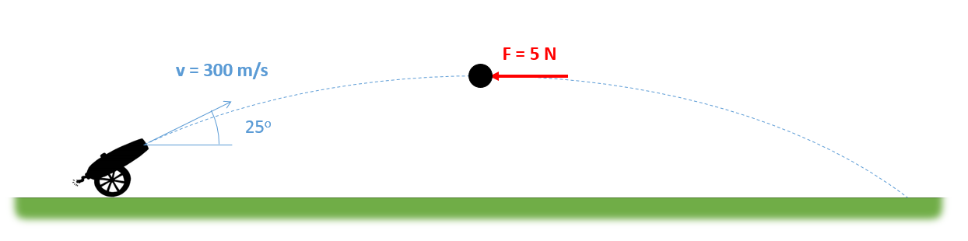

(Solution: d = 6470 m)

Problem 9.3

A 1 kg block sits on a rotating table as shown below. If the static coefficient of friction is assumed to be .4, what is the maximum angular velocity ($\dot{θ}$) that can be achieved before the block begins to slip?

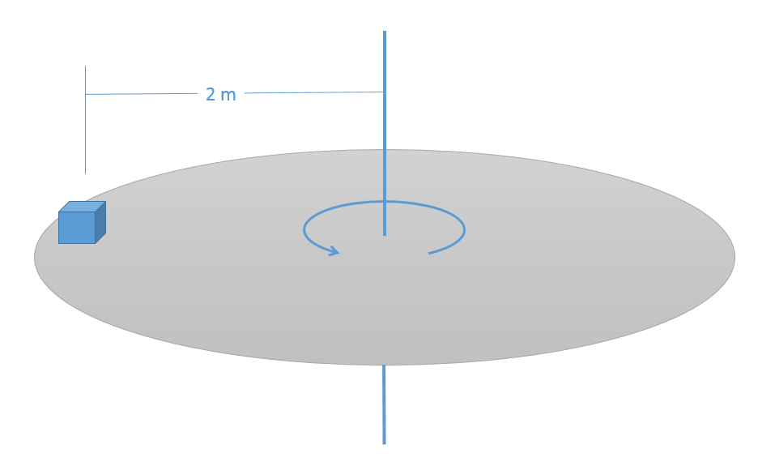

(Solution: $\dot{θ}=1.4\frac{rad}{s}$)

Problem 9.4

A 5 kg instrument is held via a cable to a space station. The instrument and space station are both rotating at a rate of .5 rad/s when the space station begins retracting the cable at a constant rate of .25 m/s.

1. What is the tension in the cable at this instant?
2. What will the angular acceleration of the cable be ($\ddot{θ}$)?

(Hint: there are no forces in the theta direction)

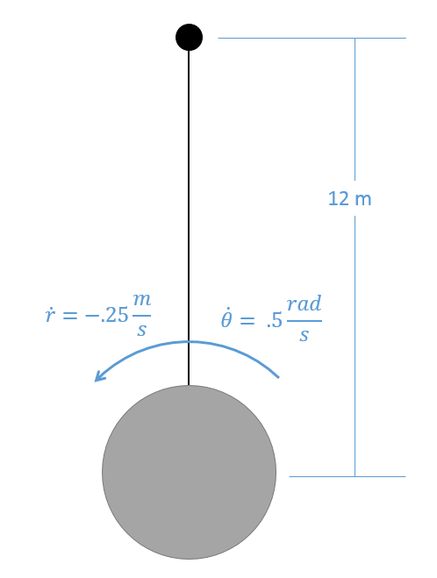

(Solution: T = 15 N, $\ddot{θ}=.0208\frac{rad}{s^{2}}$)

Problem 9.5

The SUV shown below has an initial velocity of 90 ft/s. It slams on it’s brakes, coming to a stop over a 300 ft distance. If the car has a weight of 3500 lbs and as center of mass as shown below, what are the normal forces at the front wheels? What are the normal forces as the back wheels?

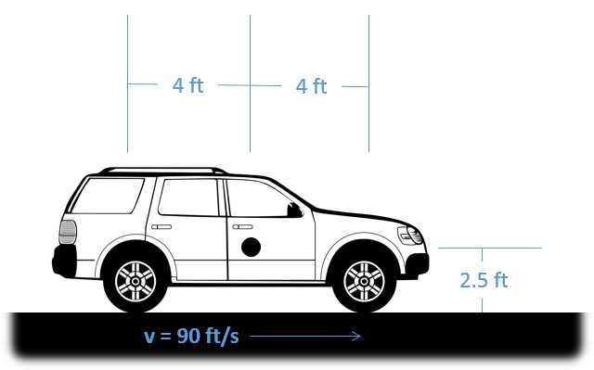

(Solution: FNR = 1291.4 lbs, FNF =2208.6 lbs)

Problem 9.6

The flywheel from problem A2.6 (see this problem for more details) is rotating at a rate of 1200 rpm. What is the torque required to stop the flywheel in .5 seconds without the drilled holes? What is the torque required to stop the flywheel with the drilled holes?

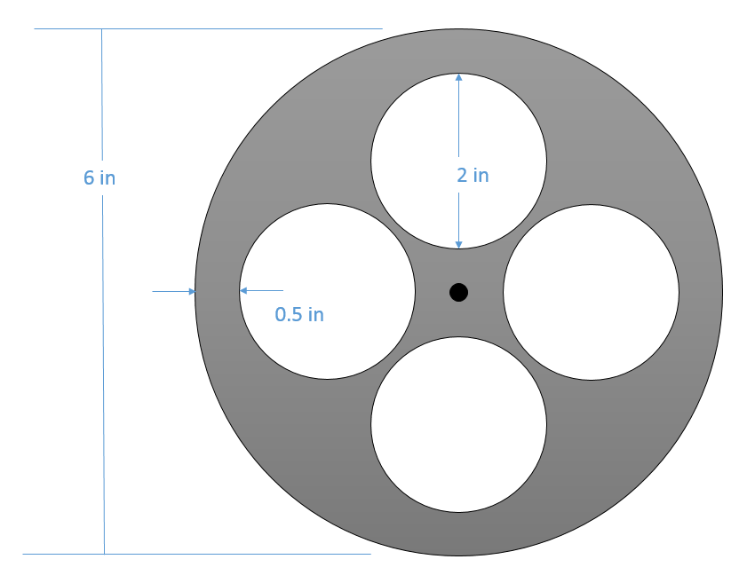

(Solution: without holes: $T=-3.66 ft lbs$, with holes: $T=-2.66 ft lbs$)